1. pwd
Use the pwdcommand to find out the path of the current working directory (folder)
you’re in.

2. cd
To navigate through the Linux files and directories, use the cd . It requires either the
full path or the name of the directory, depending on the current working directory that
you’re in

● cd ..(with two dots) to move one directory up
● cdto go straight to the home folder
● cd- (with a hyphen) to move to your previous directory

3. ls
The lscommand is used to view the contents of a directory. By default, this
command will display the contents of your current working directory.

● ls -R will list all the files in the sub-directories as well
● ls -a will show the hidden files
● ls -al will list the files and directories with detailed information like the permissions,
size, owner, etc.
● ls -t lists files sorted in the order of “last modified”
● -r option will reverse the natural sorting order. Usually used in combination with
other switches such as ls -tr. This will reverse the time-wise listing.
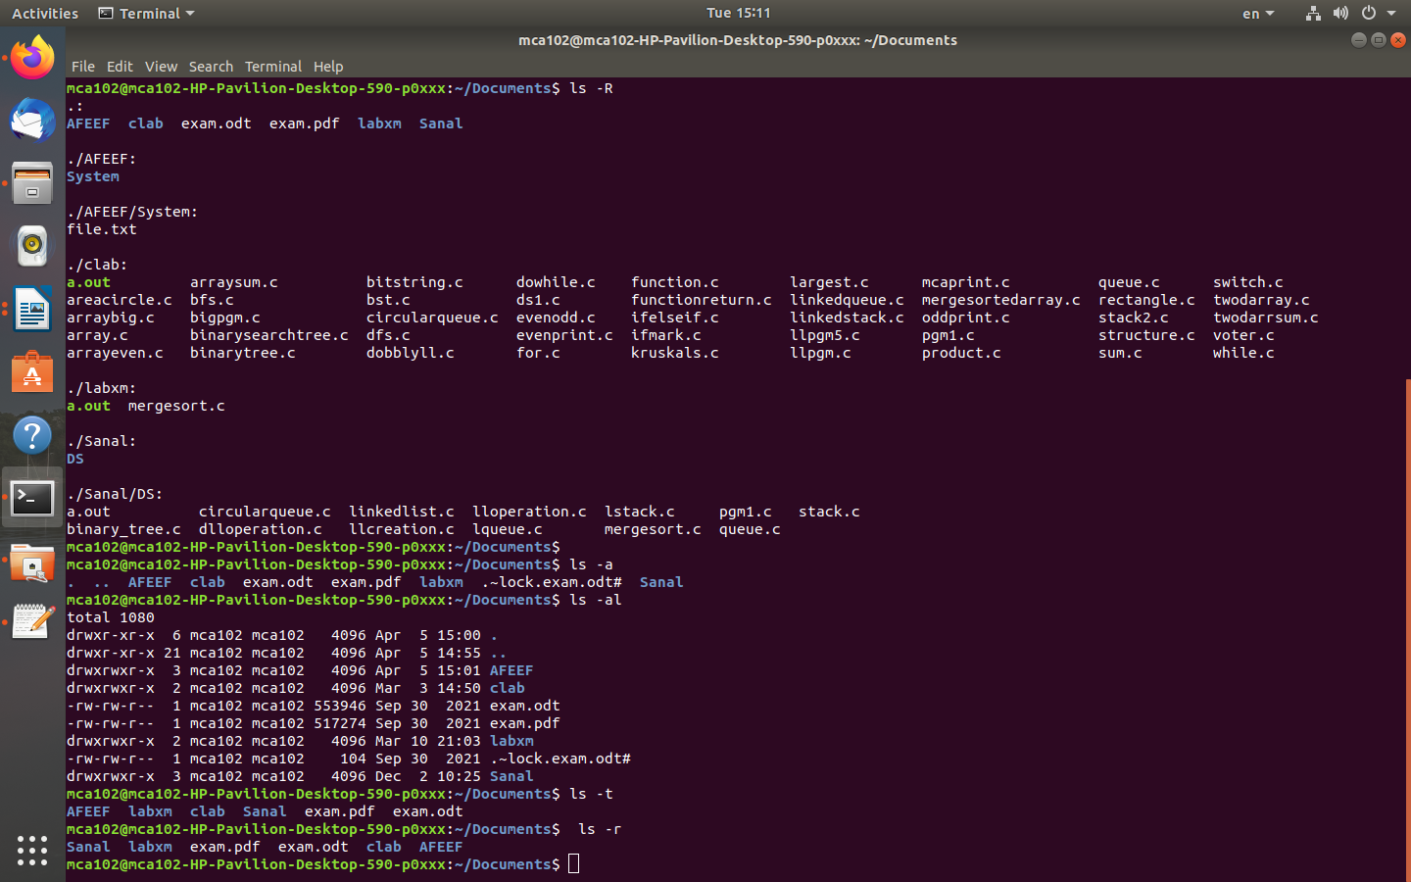

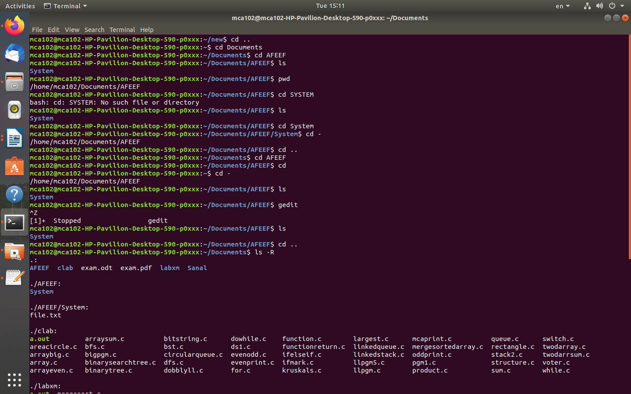

4. cat
cat(short for concatenate) is one of the most frequently used commands in Linux. It is
used to list the contents of a file on the standard output stdout . To run this command,
type cat followed by the file’s name and its extension.
● cat> filename creates a new file
● cat filename1 filename2>filename3 joins two files (1 and 2) and stores the
output of them in a new file (3)
● to convert a file to upper or lower case use, cat filename | tr a-z A-
Z>output.txt 5. cp
Use the cpcommand to copy files from the current directory to a different directory. For
instance, the command cp scenery.jpg /home/username/Pictures would create a copy
of scenery.jpg (from your current directory) into the Pictures directory.
● cp -i will ask for user’s consent in case of a potential file
overwrite. ● cp -p will preserve source files’ mode, ownership
and timestamp.
● cp -r will copy directories recursively.
● cp -u copies files only if the destination file is not existing or the source file is newer
than the destination file

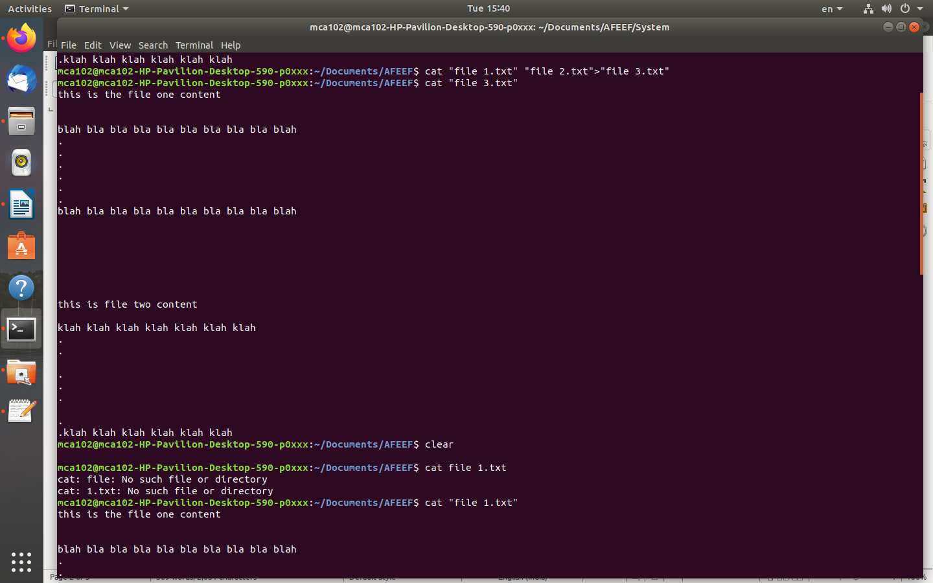

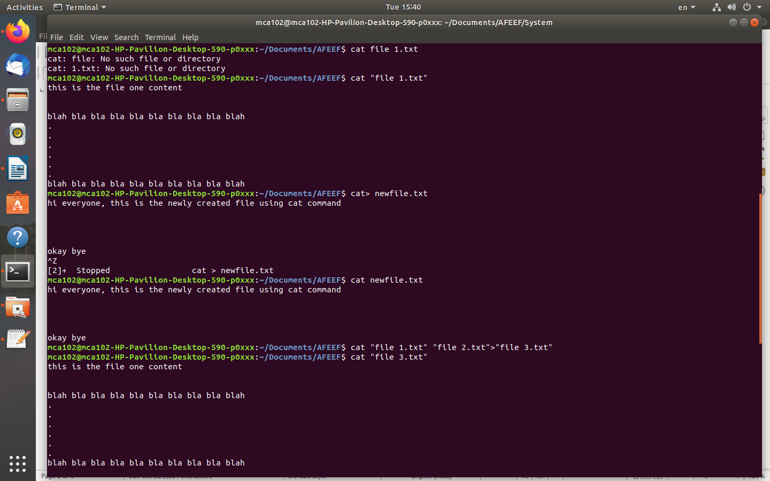

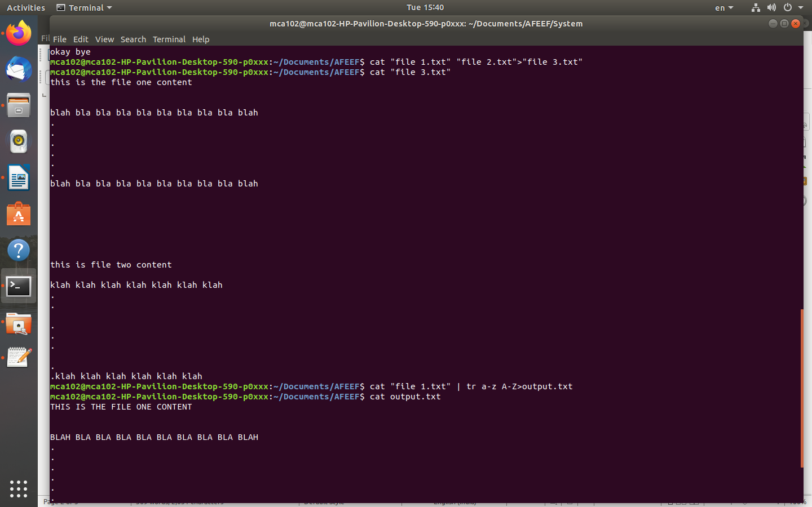

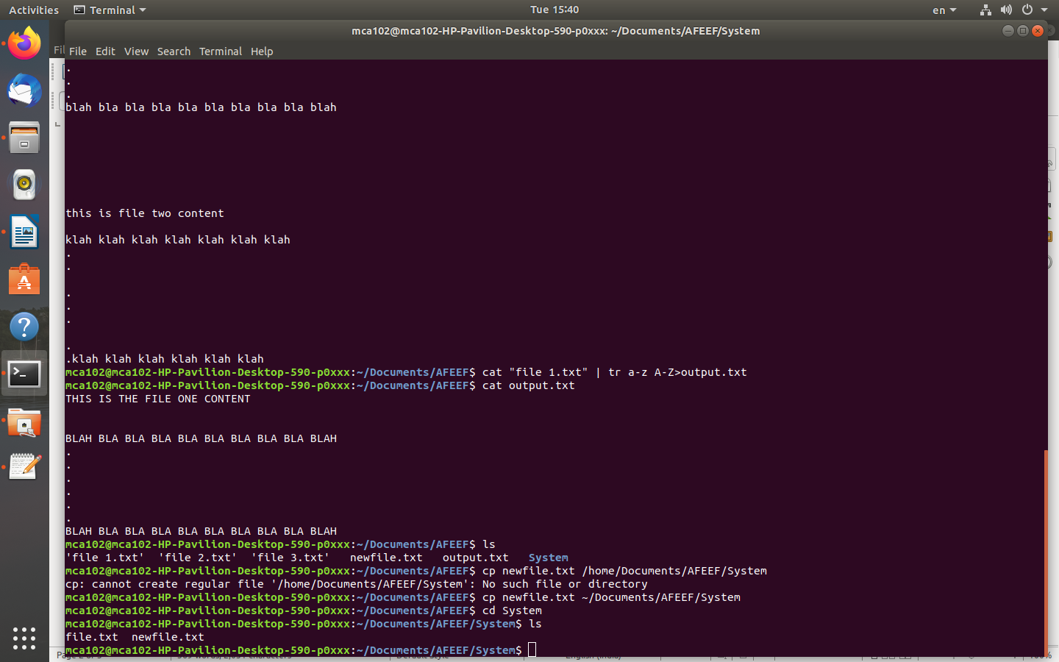

6. mv
The primary use of the mv command is to move files, although it can also be
used to rename files.

7. mkdir
Use mkdircommand to make a new directory
● To generate a new directory inside another directory, use this Linux basic
command mkdir Music/Newfile
● use the p (parents) option to create a directory in between two existing directories.
For example, mkdir -p Music/2020/Newfilewill create the new “2020” file.
8. rmdir
If you need to delete a directory, use the rmdircommand. However, rmdir only allows
you to delete empty directories.
9. rm
The rmcommand is used to delete directories and the contents within them. If you only
want to delete the directory — as an alternative to rmdir — use rm -r.

10. touch
The touch command allows you to create a blank new file through the Linux
command line. As an example, enter touch /home/username/Documents/Web.html
to create an HTML file entitled Web under the Documents directory.

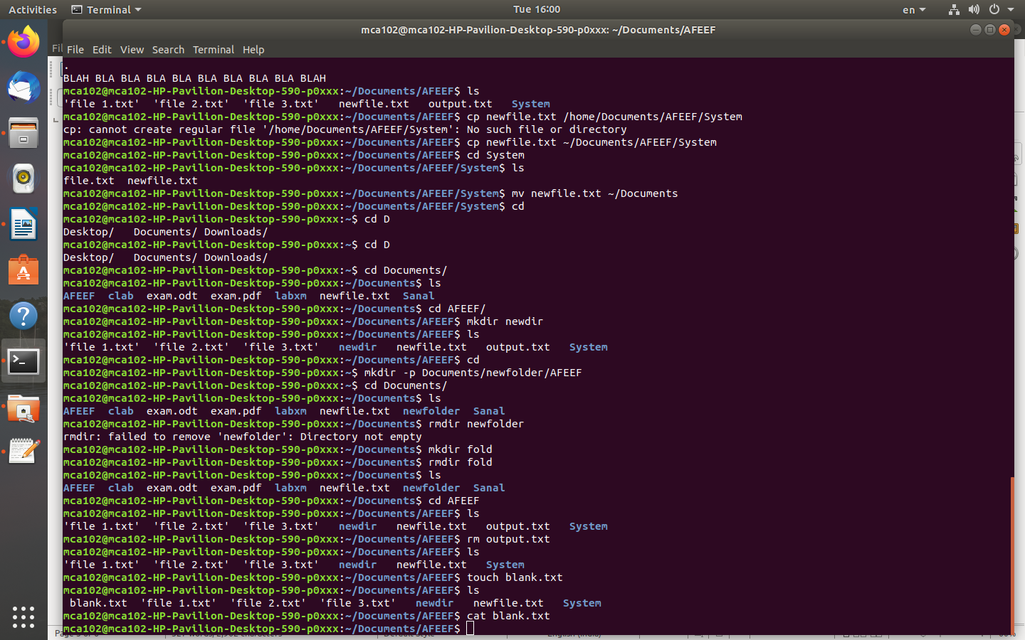

11. locate
Networking And System Administration Lab
You can use this command to locate a file, just like the search command in Windows.
What’s more, using the -i argument along with this command will make it case-
insensitive, so you can search for a file even if you don’t remember its exact name.
12. find
Similar to the locate command, using find also searches for files and directories.
The difference is, you use the find command to locate files within a given
directory

13. grep
Another basic Linux command that is undoubtedly helpful for everyday use is grep.
It lets you search through all the text in a given file.

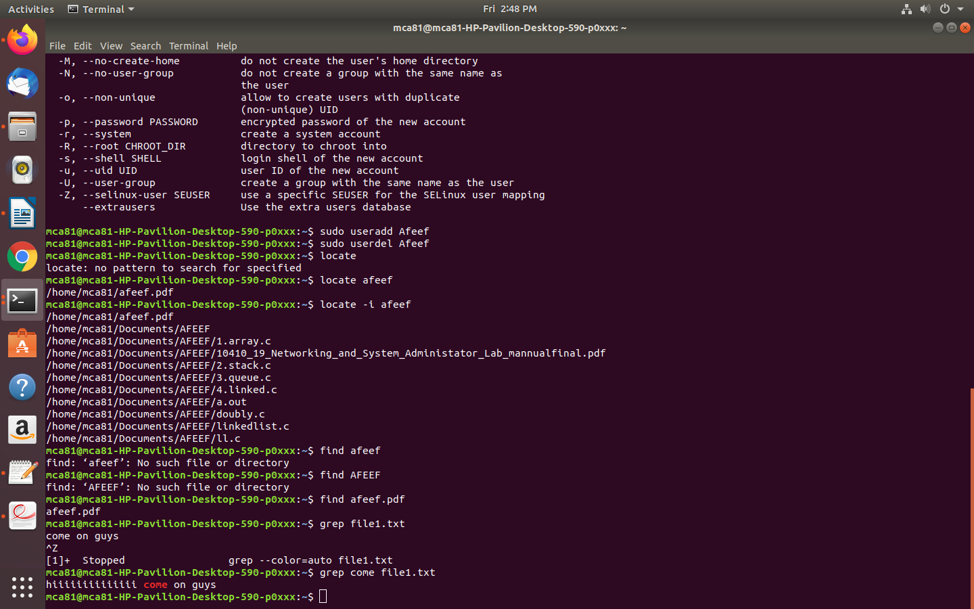

14,15,16
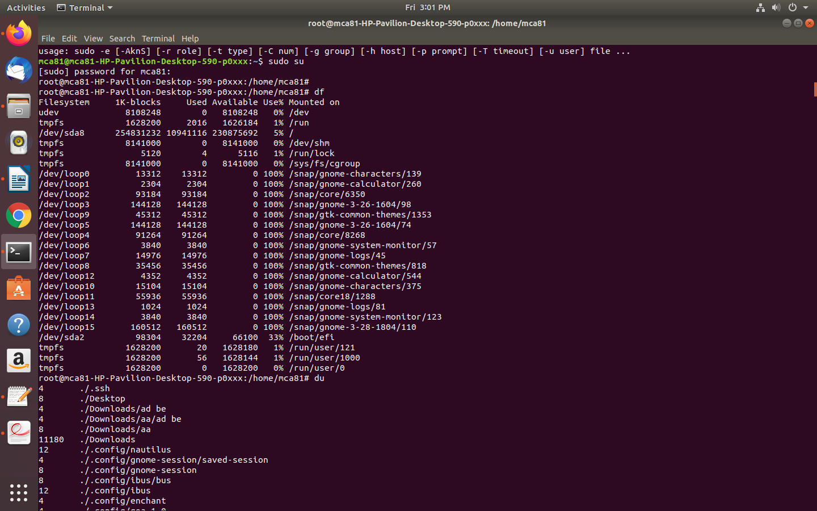

17, 18,ping
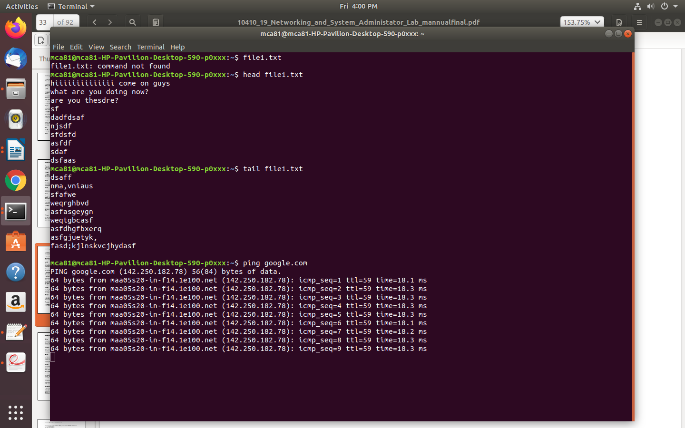

26.wget,uname,top

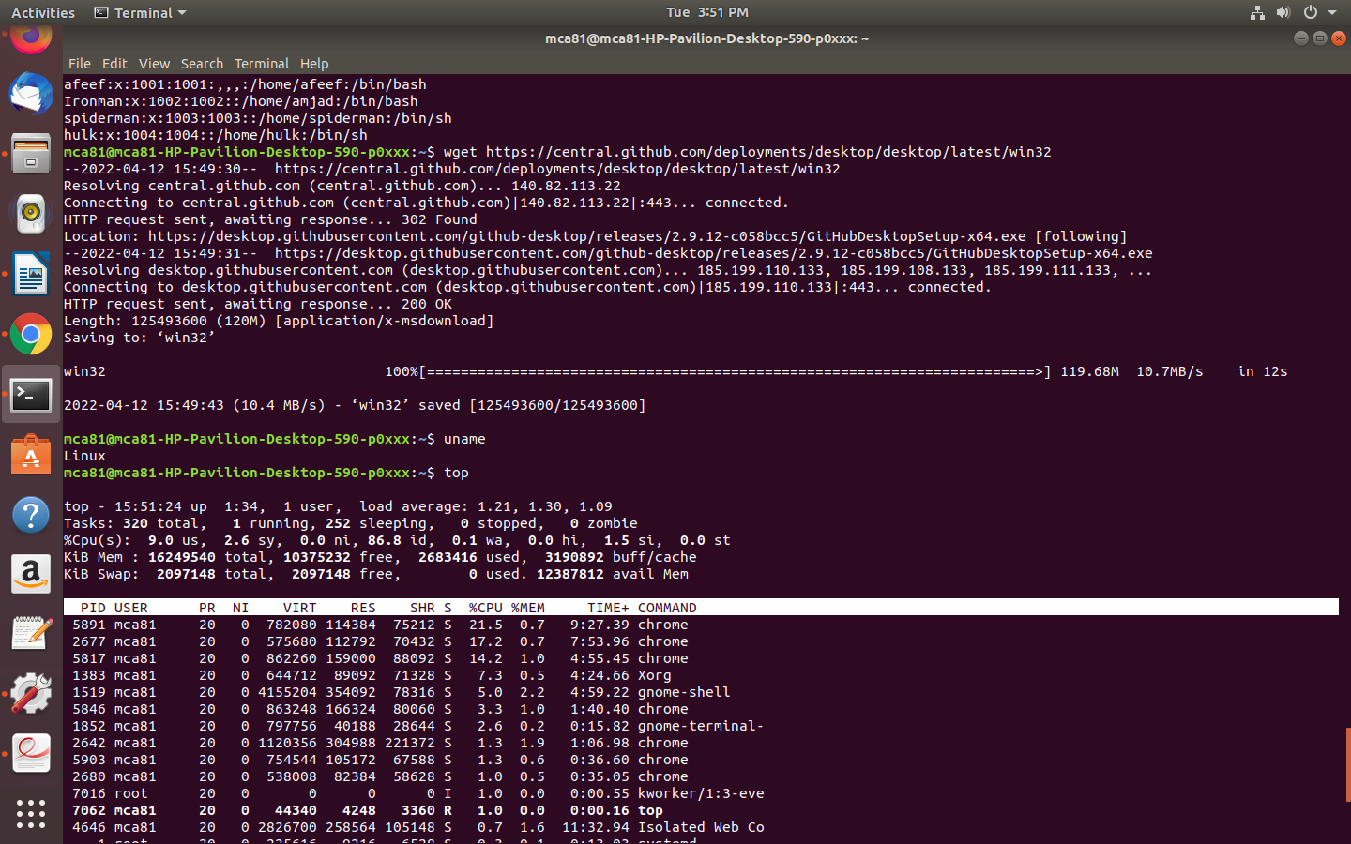
30 man
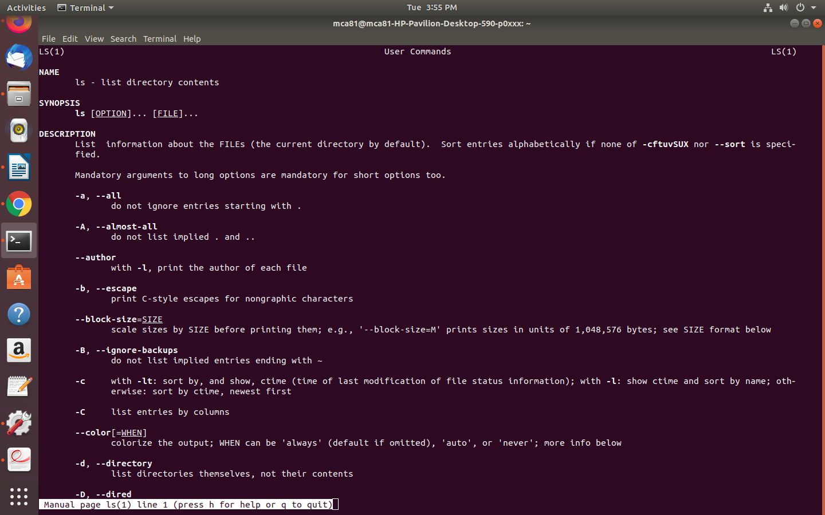
29 history

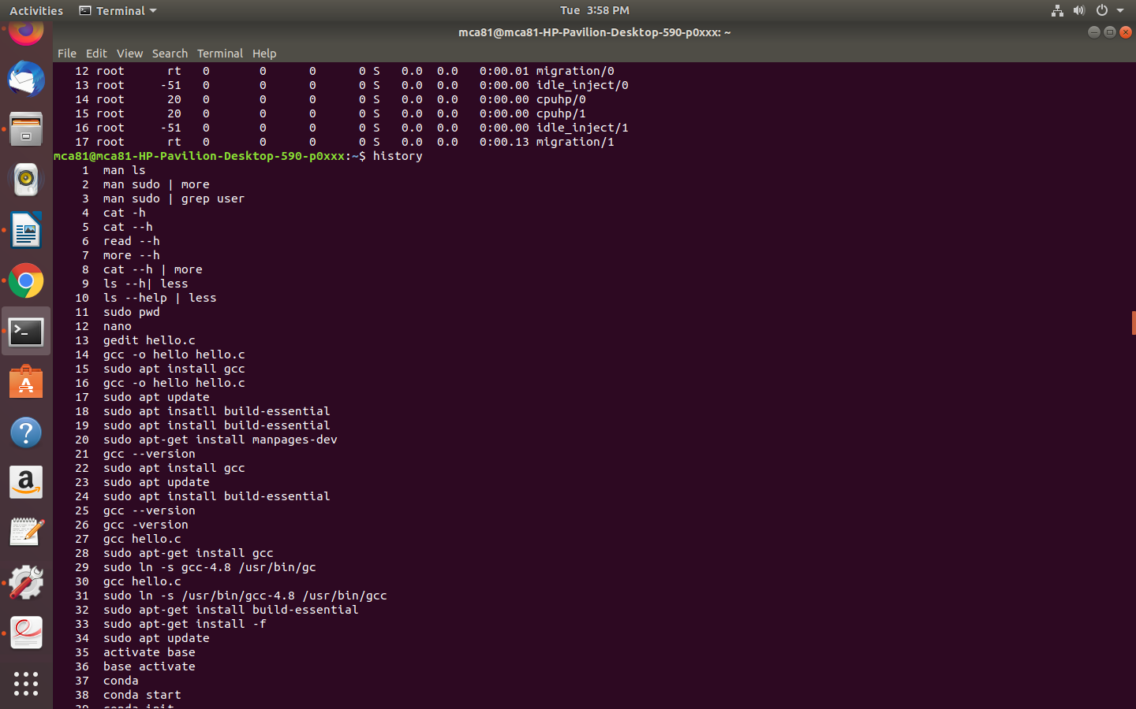
31 echo

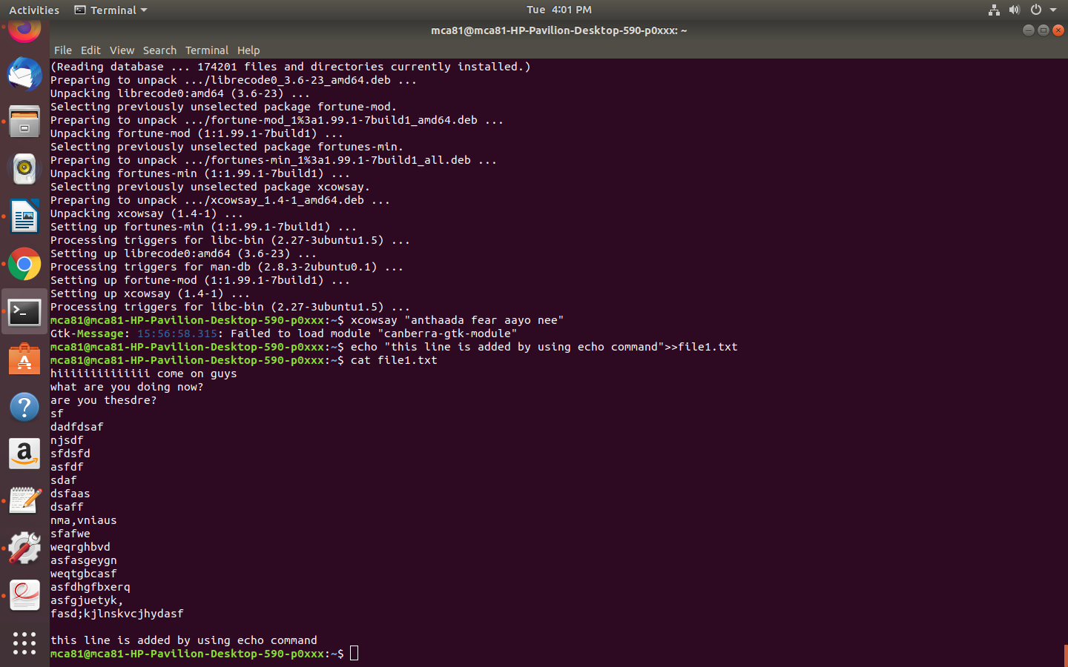
32. zip unzip
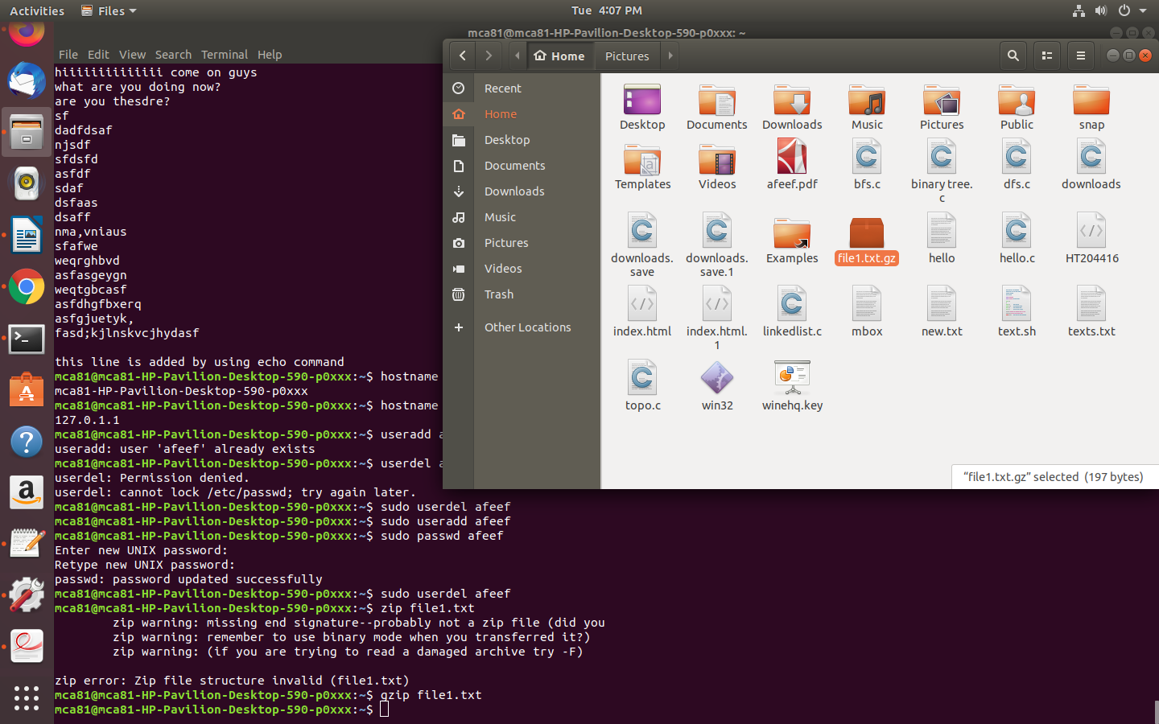

33. hostname, hostname -i
34. useradd,userdel

